***Unix Assignment Questions***

### **Basic File Operations:**

* **Q1:** Create a new directory called project in your home directory. Inside the project directory, create two subdirectories named src and bin.

Ans- # Create the project directory in your home directory

mkdir ~/project

# Create src and bin subdirectories inside the project directory

mkdir ~/project/src ~/project/bin

* **Q2:** Create a text file named notes.txt in the src directory and add some text into it using the echo command. Display the contents of the file.

Ans- # Create the notes.txt file in the src directory and add some text

echo "This is a sample note for the project." > ~/project/src/notes.txt

# Display the contents of notes.txt

cat ~/project/src/notes.txt

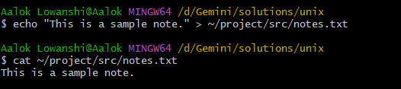

### **2. Working with File Permissions:**

* **Q3:** Create a file named data.txt. Set the permissions so that:
  + The owner can read and write.
  + The group can read.
  + Others have no permissions.

Ans- # Create the file data.txt

touch data.txt

# Set the permissions

chmod 640 data.txt

* **Q4:** Change the permissions of data.txt to be readable, writable, and executable by everyone.

Ans - # Change permissions to allow read, write, and execute for everyone

chmod 777 data.txt

### **3. File Searching and Manipulation:**

* **Q5:** Using the find command, search for all .txt files in your home directory.

Ans- find ~ -type f -name "*.txt"

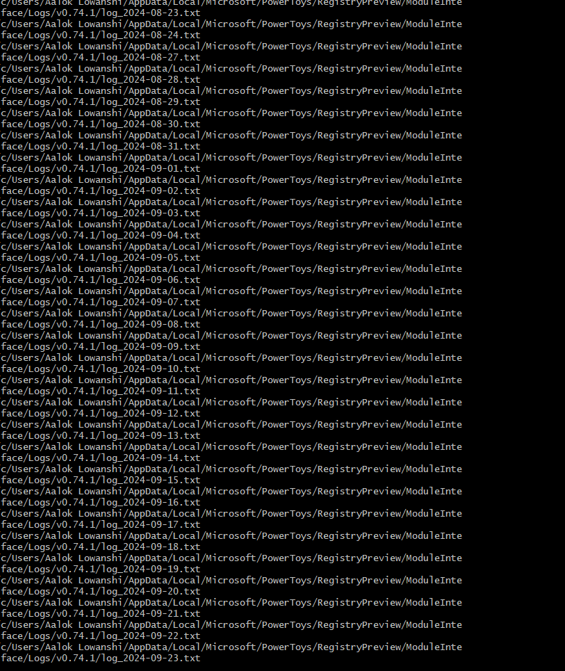

* **Q6:** Find all files in the /etc directory that were last modified in the last 7 days.

Ans- find /etc -type f -mtime -7

* **Q7:** Use the grep command to search for the word "error" in the /var/log/syslog file. Display the lines where this word occurs.

Ans- grep "error" /var/log/syslog

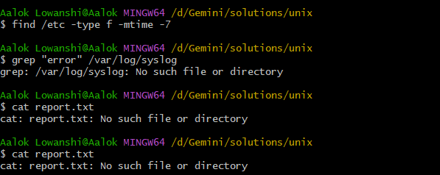

### **4. Text File Operations:**

* **Q8:** Display the contents of a file report.txt line by line using the cat, more, and less commands.

Ans- # Using cat

cat report.txt

# Using more

more report.txt

# Using less

less report.txt

* **Q9:** Use head and tail commands to display the first 10 and last 10 lines of a file named log.txt.

Ans- # Display the first 10 lines

head -n 10 log.txt

# Display the last 10 lines

tail -n 10 log.txt

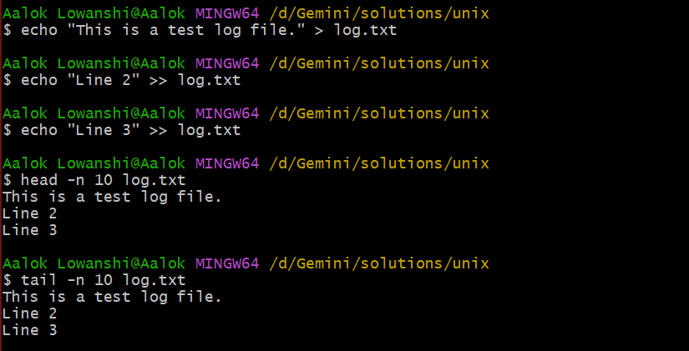

* **Q10:** Create a file named names.txt containing a list of names. Use sort to display the names in alphabetical order.

Ans- # Create names.txt and add a list of names

echo -e "Alice\nCharlie\nBob\nDavid" > names.txt

# Sort the names in alphabetical order

sort names.txt

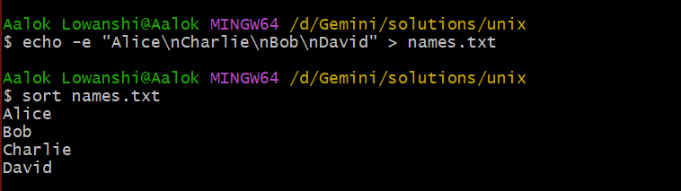

* **Q11:** Use the wc command to count the number of words, lines, and characters in a file data.csv.

Ans- wc data.csv

### **5. Process Management:**

* **Q12:** List all running processes using the ps command.

Ans- ps aux

**6. System Information:**

* **Q13:** Display the current date and time using the date command.

Ans- date



* **Q14:** Use the df command to display disk space usage.

Ans- df -h

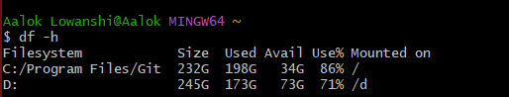

* **Q15:** Use the uname command to display your system’s information (e.g., OS type, version).

Ans- uname -a

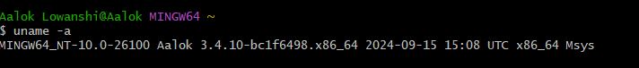

* **Q16:** Display the current system uptime using the uptime command.

Ans- cat /proc/uptime

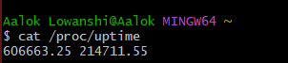

### **7. Network Commands:**

* **Q17:** Use the ping command to check if a remote server (e.g., google.com) is reachable.
* 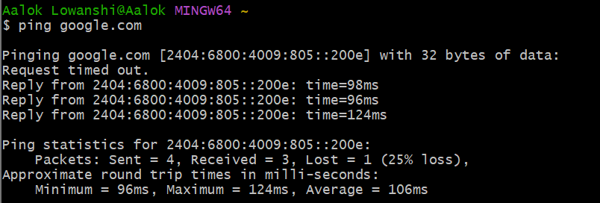**Q18:** Use the ifconfig or ip a command to display the network configuration of your system.

Ans- ifconfig

Output :

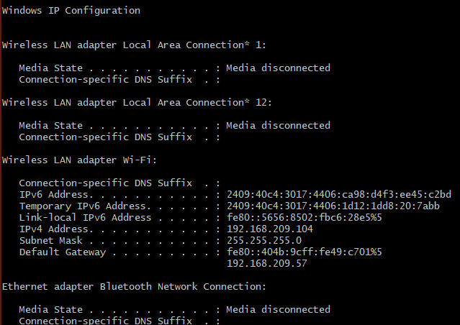

* **Q19:** Display the active network connections using the netstat command.

Ans- netsat -tuln